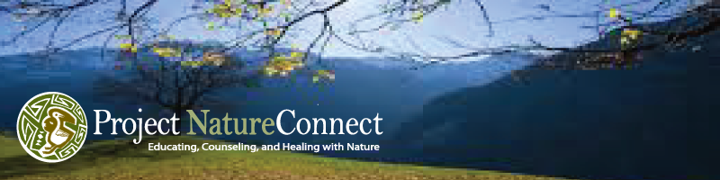

Benefit from creating heartfelt moments in natural areas that unify and resolve any conflict.

www.ProjectNatureConnect.com
nature@interisland.net
360-378-6313

PRISTINE TRUTH NATURENESS AND ECOPSYCHOLOGY APPLICATION
www.ecopsych.com/applicationpristine.docx

Dear Seeker of Nature’s Pristine Truth,

Thanks for your interest in Natureness, the self-correcting essence of Nature described at www.PristineTruth.net including the article How to Let Earth Save Us.

To turn over a new “leaf” once meant the leaf of a page in a publication. This application is for folks who, instead, turned over that new leaf in the prerequisite legacy article Pristine Truth Ecopsychology: the Natureness Remedy. The leaf becomes pure attraction energy there () and it continues in this application.

Purpose This application aims to celebrate and support authentic parts of your life that you love and want to be more respected, supported and credible.

Reading the www.PristineTruth.com website and its links of interest is also a prerequisite to applying that familiarizes you with the program’s mutually beneficial commitments to people and the natural world.

APPLICANTS NAME:

Email Telephone Age (optional) Occupation

Organization and social media affiliations

Highest formal education

Central interest, training or discipline

Your Goal ( course, training, degree level, internship, job, career, grant, community)

Do you have somebody to do this program with you as a mutually helpful partner (s)? (contact Mike, 360-378-6313)

Would you be interested in receiving financial honorariums for helping others become aware of what you learn or value in our program?

Can you donate to the program or intern or assist other participants to the benefit of all?

Do you recognize that our Society excessively educates and counsels itself/us to be and endure today’s conflicts, insanity and corruption? That its “Love,” “Nature,” “Gods,” and “Honesty” are long-term destructive rather than trustable, and that anytime anywhere the Pristine Truth of Natureness transforms this catastrophe into its nature-connected remedy?

Do you think your nature, your “inner child” (is it really a child?) has ever been abused? Do you remember the incident(s)? Do you want to help Nature help you and others prevent and recover from these traumas that we hide in us, however, they seldom disappear?

Please call us or invite us to call you with regard to any of the above 360-378-6313 nature@interisland.net

I have read, explored and I’m enthusiastic about

( ) Release: How to Let Earth Save us
www.ecopsych.com/tfrelease.docx

( ) Nature Connected Psychology announcement
www.ecopsych.com/psychologypost

( ) Overview Article How to Let Earth Save Us.

( ) Article: Pristine Truth Ecopsychology: the Natureness Remedy
www.ecopsych.com/IJENATGUIDE.pdf

( ) Homepage www.PristineTruth.com
www.ecopsych.com/homepagepristine/

( ) Article: The Web-of-Life Natural Attraction Blueprint
www.ecopsych.com/webstring1000nat.html

( ) Person/Planet Benefits
www.ProjectNatureConnect.com/benefits

The Nature-Connecting terms or concepts that are familiar to me:
( ) Pristine Truth ( ) Natureness ( ) Natural Attraction ( ) NNIAAL
( ) Earth Misery, ( ) Nature is wordless/Humanity is verbal, ( ) Flowchart
( ) Nature exists and is alive, ( ) I exist and I’m alive ( ) Spacetiming
( ) Project NatureConnect ( ) My greatest trustable truth ( ) Godness
( ) The Webstring Blueprint ( ) Michael J. Cohen ( ) 54-senses
( ) Green Switch ( ) Wrangler ( ) Earth & Humanity “conspire”

APPLICANT’S STATEMENT

Based on Pristine Truth’s purpose, it is reasonable for me to sense and feel that my life interests and loves deserve to be accredited so they may help me and others achieve our goals in environmentally and socially responsible ways.
( ) yes ( )no

Comments or questions: ____________

Below, please explain how, what, when, where, and why your interest(s) are heartfelt with respect to the objectives of Pristine Truth and Natureness that you found in this application’s links.

Your statement can become the central focus of whatever you do for and with your accreditation or training.

The more honest, compelling, and complete your description, the more it can be the helpful point source of your thoughts and feelings, writings, certification, funding, or degree and role in increasing personal, social, and environmental well-being.

Your Statement (800 word limit):

When completed, please email or attach this information to us. We are looking forward to helping you strengthen your and everything else’s pristine truth and vice versa.

Project NatureConnect
nature@interisland.net
360-378-6313

