Akamai University
Statement of Accreditation
Akamai University is dedicated to betterment of the human condition and sustainability of the planet. Our mission is founded on the premise that amelioration of world problems and the creation of sustainable lifestyles and global practices are the hallmarks of responsible individual and corporate world citizenship.
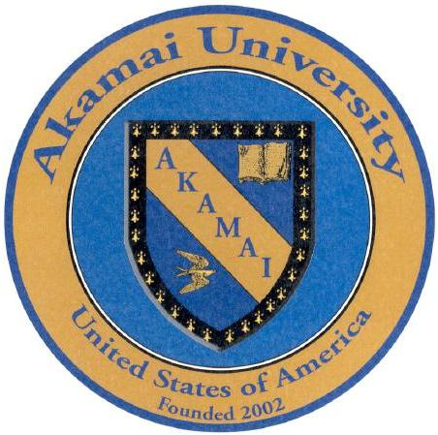Akamai is legally established by corporate charter and operating in good standing as a non-profit degree-granting institution under the laws and regulations of the United States of America and the State of Hawaii. Akamai operates as a federal and state tax-exempt institution of higher learning for the purpose of providing advanced studies, research and community service worldwide. Akamai University is an international university with academic, corporate, and community service affiliations in many nations. Our degrees are structured to be equivalent to degrees awarded by reputable institutions worldwide. Akamai University’s official documents are available online.
Akamai University School Charter
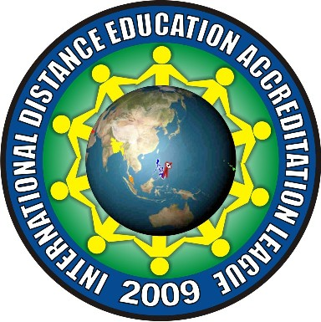Akamai is internationally accredited by the International Distance Education Accreditation League (IDEAL) in the Republic of the Philippines. IDEAL is a member of the National Network of Quality Assurance Agencies (NNQAA), an association of recognized accreditors in the Philippines. Akamai’s accreditation with IDEAL is provisional for a three year period through 30 June 2013, prior to which time an official onsite visit in Hawaii must be completed. Because Akamai is an international institution with over 90% of our programs conducted through distance-based education, our focus has been on achieving international recognition and accreditation.
IDEAL Letter of Accreditation
Akamai University is not accredited by an accrediting agency or association recognized by the US Department of Education.
Before undertaking any program of studies in higher education or training, Akamai University strongly advises interested applicants to consult with licensing authorities, professional associations, colleges and universities, and prospective employers to determine with clarity if the desired degree program will meet their professional requirements.

